Sulphur Springs High School Mr. Gerald Grafton
School Year: 2015 - 2016 Conference: 1st Period (8 am – 8:46 am)
Room: 107 email: ggrafton@ssisd.net
903-885-2158 www.sshsmathematicsgrafton.weebly.com
AP Calculus Syllabus
SSISD Vision
Educating All Students to Their Fullest Potential

SSISD Mission
The mission of the Sulphur Springs Independent School District is to provide students with the skills that will prepare them to adapt and excel in a fast-changing world, enabling them to lead productive lives. The district shares with parents and the community the responsibility of promoting high standards and expectations as we provide opportunities for all students within our diverse community to attain personal growth and to become lifelong learners.

Course Description
Prerequisite: Algebra I, Algebra 2, Geometry, and Pre-Calculus
The main objective of AP Calculus is to give students a rigorous and academically challenging college preparatory mathematics course. The skills of interpreting calculus on a graphical, analytical, verbal, and numerical basis are developed. In this course students will define and use limits, derivatives, and integrals. Students in this class will be preparing to take the AP Calculus Exam. Use the following link to see a full course description for AP Calculus.
http://apcentral.collegeboard.com/apc/public/repository/ap-calculus-course-description.pdf
Resources
Text: Calculus: Graphical Numeric, Algebraic (3rd Edition) by Finney, Demana, Waits, and Kennedy;
Additional Resources (Optional): Thinkwell Calculus (IPAD APP); Preparing for the AP Calculus Examination by George Best and Richard Lux; AP Calculus AB & BC by Norman Levy, PH.D; www.integralcalc.com

Prerequisites (taken from AP Course Description)
Before studying calculus, all students should complete four years of secondary mathematics designed for college-bound students: courses in which they study algebra, geometry, trigonometry, analytic geometry, and elementary functions. These functions include linear, polynomial, rational, exponential, logarithmic, trigonometric, inverse trigonometric, and piecewise-defined functions. In particular, before studying calculus, students must be familiar with the properties of functions, the algebra of functions, and the graphs of functions. Students must also understand the language of functions (domain and range, odd and even, periodic, symmetry, zeros, intercepts, and so on) and know the values of the trigonometric functions at the numbers
, and their multiples.

Course Requirements and Evaluation
Your six weeks grade will be determined in the following manner. 50% will be major grades such as unit exams and/or projects. The remaining 50% will be daily grades including but not limited to participation, completion of daily assignments, and daily quizzes.
Grading Scale
90 – 100 A
80 – 89 B
70 – 79 C
69 or below F
Course Policies
CLASSROOM EXPECTATIONS (P⁵):
1. PROMPT- Please sit in your assigned seat or area BEFORE the tardy bell rings. Then begin warm-up assignment.
2. PREPARED- Please enter our room in dress code with ALL class supplies daily. Place completed assignments in the designated area.
3. POLITE- At all times, please respect yourself, your classmates, and your teacher. Please listen attentively when others are speaking.
4. PARTICIPATE- ASK QUESTIONS! ANSWER QUESTIONS!
At the appropriate times, please share relevant ideas, help your classmates, analyze and discuss concepts and problem solving procedures and methods.
5. PRACTICE- Please spend 15 to 35 minutes DAILY completing homework, studying, reading notes and other supplemental materials.

CONSEQUENCES:
1ST Offense: Verbal Warning
2nd Offense: Detention
3rd Offense: Detention/Parent Contact
4th Offense: Referral to Principal’s Office/Parent Contact
Severe Clause: Referral to Office/Parent Contact

METHODS OF INSTRUCTION: Assignments and exercises, lectures and outlines, demonstrations, discovery exercises, unit evaluations, reading, group activities, board work.

ATTENDANCE AND TARDIES:
The Texas Education Code states “to receive credit for a class, a student is required to attend school for at least 90 percent of the days the class is offered (Section 25.092, Texas Education Code).” http://www.tea.state.tx.us. Attendance and punctuality are essential for your success in this course. Please attend class daily for your benefit. Persons entering class after the passing period will be marked tardy. Arriving to class 15 or more minutes late is considered an absence.

MATERIALS NEEDED: 3-ringed notebook and 3 dividers, paper, Graphing Calculator (recommended TI 84 or equivalent), 4-AAA batteries, graph paper, and writing utensils.
CLASSWORK/HOMEWORK
We will cover the required material and incorporate daily review of basic math skills. Any assignment not turned in at the designated time will be marked late. Papers turned in after a due date are subject to grade penalties. Please remember, if you have trouble with an assignment it is your responsibility to attend tutorials to receive the help you need.
PROVE YOUR ANSWERS
- On all assignments, quizzes and tests
- Write the problem
- Show intermediate steps
- Identify your answer with proper units/sentence
- Box or Highlight your answer
- Check your work

PAPER HEADING
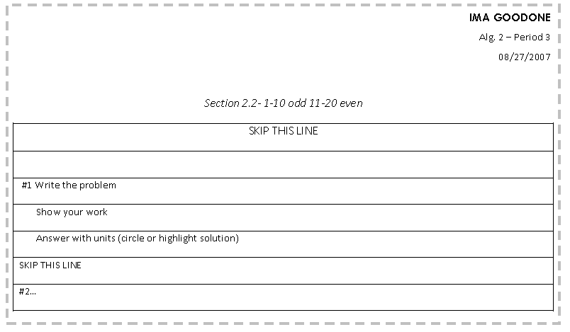

QUIZZES
- You may have a quiz at any time.
TESTS/PROJECTS
- Test dates will be posted and announced in class.
MAKE-UP WORK
- Please pick up absent work from absent bin before class begins the day you return.
- If you are absent one day, you have two days to make up the assignment(s).
- If you are absent two days, you have four days to make up the assignment(s).
- Missed tests will be completed in tutorials within one week of absence.

RETESTING
- Tests scores below 70% will be corrected DURING TUTORIALS.
- Retests will be retaken during tutorials within one week of the test.
- Student who score below their desired goal on an original test may retake for a maximum grade of 90% during tutorials.

TUTORIALS
Tutoring is before school 7:40 – 7:55 am every school day except Thursdays. Please sign in and out during tutorials.

CALCULATOR USAGE
- Using a calculator is a privilege not a right.
- Sulphur Springs High School will provide you with a calculator for your use in the classroom.
- Your assigned calculator is YOUR responsibility during the period.
- Batteries may be removed only when replacement is necessary.
- If you notice ANYTHING wrong with your calculator, it is YOUR responsibility to bring it to my attention AT THE BEGINNING OF THE PERIOD; otherwise, YOU will be responsible for the damage and replacement of the calculator. The replacement cost is approximately $125.

CELL PHONES & ELECTRONIC DEVICES: Cell phones & other electronic devices should be turned off and put away during class unless they are being used for a specified activity.

ACADEMIC INTEGRITY - By taking this course, the student declares that he/she will be the author of ALL work submitted for the course. Allowing another individual to complete assignments constitutes fraud and academic dishonesty. Should such behavior come to the attention of the instructor, the student will receive a 0 for the assignment.
Office Hours
My conference period at the high school is 1st period from 8 am to 8:46 am.
IMPORTANT DATES:
AP TEST: Thursday, May 5, 2016

SSHS BELL SCHEDULE:
REGULAR SCHEDULE |  |  |  |  | PEP RALLY SCHEDULE
1st PERIOD | 8:00 | - | 8:47 |  | 1st PERIOD | 8:00 | - | 8:43
2nd PERIOD | 8:52 | - | 9:39 |  | 2nd PERIOD | 8:48 | - | 9:31
3rd PERIOD | 9:44 | - | 10:31 |  | 3rd PERIOD | 9:36 | - | 10:19
4th PERIOD | 10:36 | - | 11:24 |  | 4th PERIOD | 10:24 | - | 11:07
5th PERIOD | 11:24 | - | 12:54 |  | 5th PERIOD | 11:07 | - | 12:37
A LUNCH | 11:24 | - | 11:54 |  | A LUNCH | 11:07 | - | 11:37
B LUNCH | 11:54 | - | 12:24 |  | B LUNCH | 11:37 | - | 12:07
C LUNCH | 12:24 | - | 12:54 |  | C LUNCH | 12:07 | - | 12:37
6th PERIOD | 12:59 | - | 1:46 |  | 6th PERIOD | 12:42 | - | 1:25
7th PERIOD | 1:51 | - | 2:38 |  | 7th PERIOD | 1:30 | - | 2:13
8th PERIOD | 2:43 | - | 3:30 |  | 8th PERIOD | 2:18 | - | 3:01
 |  |  |  |  | PEP RALLY | 3:05 | - | 3:30

Year at a Glance
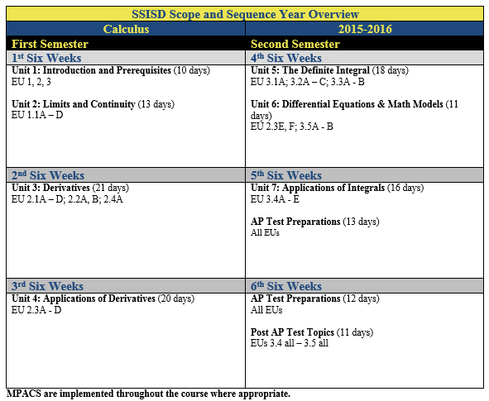
THE ABOVE SCHEDULE, POLICIES, PROCEDURES, AND ASSIGNMENTS IN THIS COURSE ARE SUBJECT TO CHANGE IN THE EVENT OF EXTENUATING CIRCUMSTANCES.

Student, Parent, Teacher Contract

STUDENT: I have read the rules, procedures, classroom discipine plan and calculator usage. I understand them. I will honor this contract during our time together for AP Calculus.

______________________________ ______________________________
Please PRINT name here Please SIGN name here

PARENT: My child and I have discussed this contract. I undersand it and will support it.

______________________________ ______________________________
Please PRINT name here Please SIGN name here

PARENT: I give my child permission to view a film in class that the teacher has chosen to show. I acknowledge this film may possibly be rated PG-13 or PG and that the teacher will use discretion in selecting a film appropriate for the students. I understand this film will pertain to the subject matter of the class.

______________________________ ______________________________
Please PRINT name here Please SIGN name here

Parent Daytime Phone (_____)___________ Parent Evening Phone (_____)___________

e-mail address: Please print clearly _________________________________________________

Additional information/Comments __________________________________________________

TEACHER: I will be fair and consistent with your student and all students in his/her class.

Mr. Gerald Grafton_____ __________________
Please PRINT name here Please SIGN name here

Please return this page to Mr. Grafton on or before Friday, August 29, 2014

             
